Lab 05 Advanced GIS

Arielle Wood

**1.1.1** 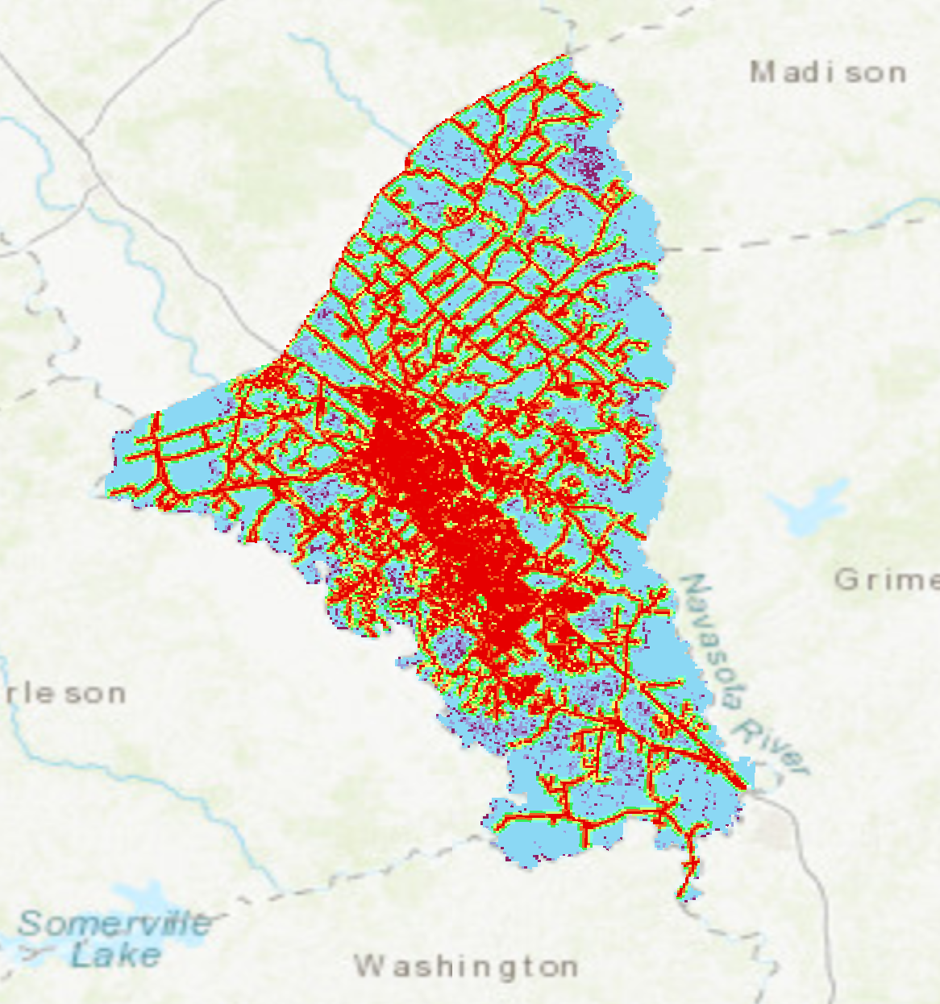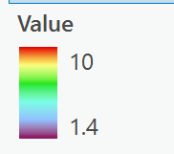

**1.2**

**1. Include your conceptual workflow that highlights data, processing, suitability ranking and suitability-site modeling. Describe the overall workflow.**

Reclassify

Road Suitability

Multi Ring Buffer to gauge distances from a major road

Add the suitability information together to begin Analysis

Flood Suitability

Reclassify

Use Slope tool to redefine the DEM

The workflow shows the basic concept behind the work to create the Suitability Site Model from which Analysis can begin. To break down the exact steps: first, the road data needs to be added, it was then put through a multi ring buffer to decide the distances to be captured. From there, it was transformed from a polygon to a raster. It was lastly, reclassified to have a distinct ranking from 10, 8, 6, 4, 2, and 1. The DEM was then added to the map. A slope function was performed on the DEM, and it was reclassified in a similar manner as the road data. The raster calculator was then used to determine the weights of the two significant pieces of data. The last step was the extract by mask to add the data together to create information.

**2. Justify your choice of data and processing for producing each suitability ranking.**

In the available data, I found it significant to use the road data for easy access and the topography data to analyze the risk for the landscape in terms of flooding and in terms of flat land. Building a house infers that there is solid, flat land available. This may not be the case with every piece of land available. Thus, topography is a significant factor. The road data is important for accessibility. How far is each piece of land from a highway, and how far would a commute realistically be. I ranked the road data from 100 to 500 meter distances in increments of 100 meters. I ranked the topography from slope intervals of 2 to 32 in changing increments. I tried a few different slope intervals and the data blurred together for many of them. This is why I chose a scale from 2 to 32.

**3. How can you justify the weights that you used in your model?**

I decided to rank the roads slightly more significantly than the slope. The slope increments were minimal in visualized change. This is another way of saying the majority of the slopes were similar. Since this was mostly uniform, I decided the data that illustrated a bigger change was more important. I, also, weighted roads more than the topography because the commute and remoteness of a piece of land is something the user will constantly notice and potentially be frustrated by. The topography is something that may fade into the background with time. I weighted the roads as 60% and the topography as 40%.

**4. Do different weights produce different index results?**

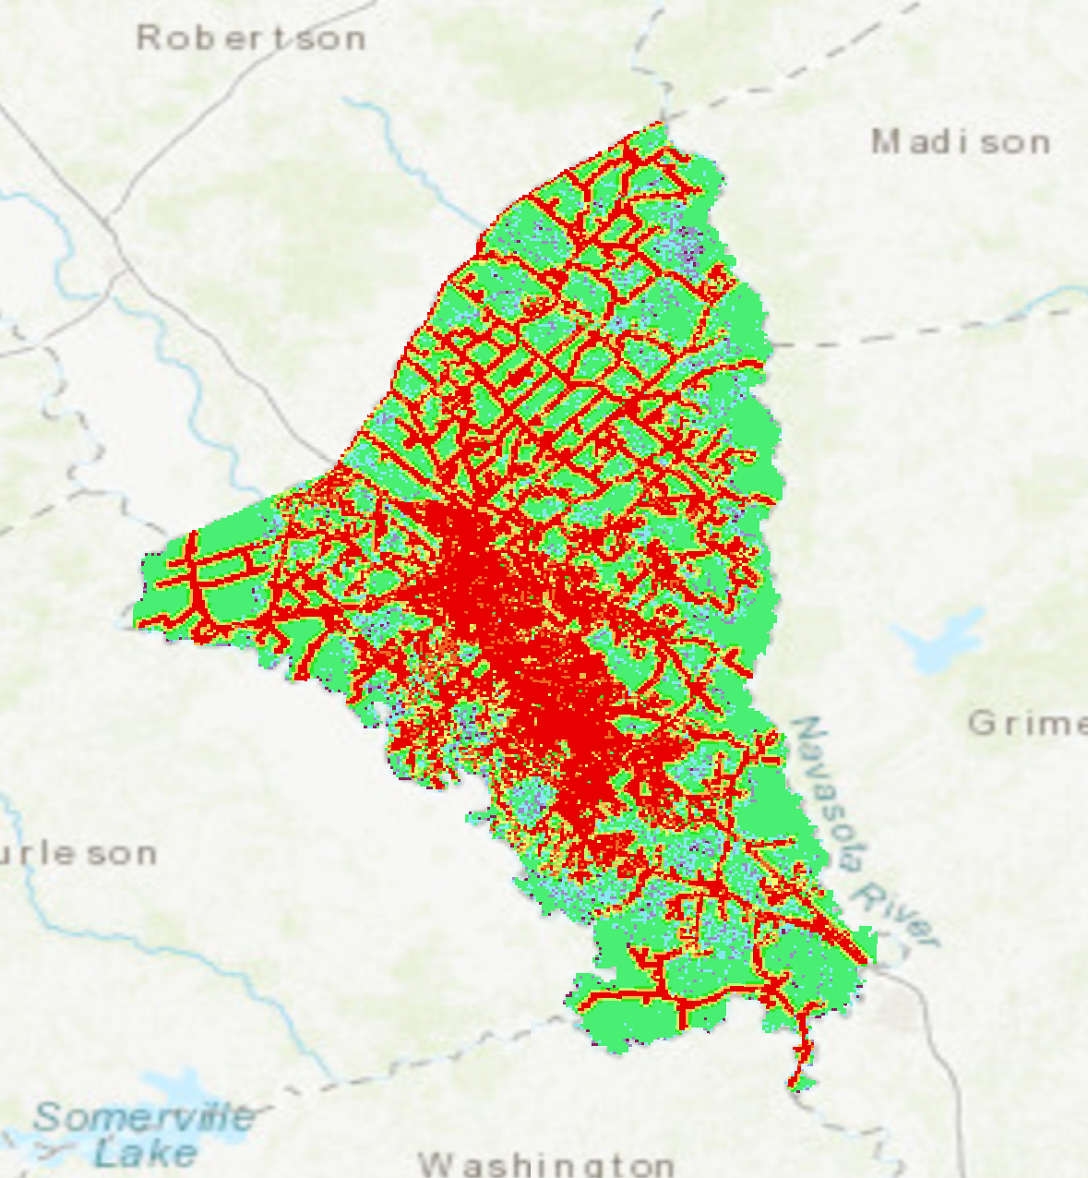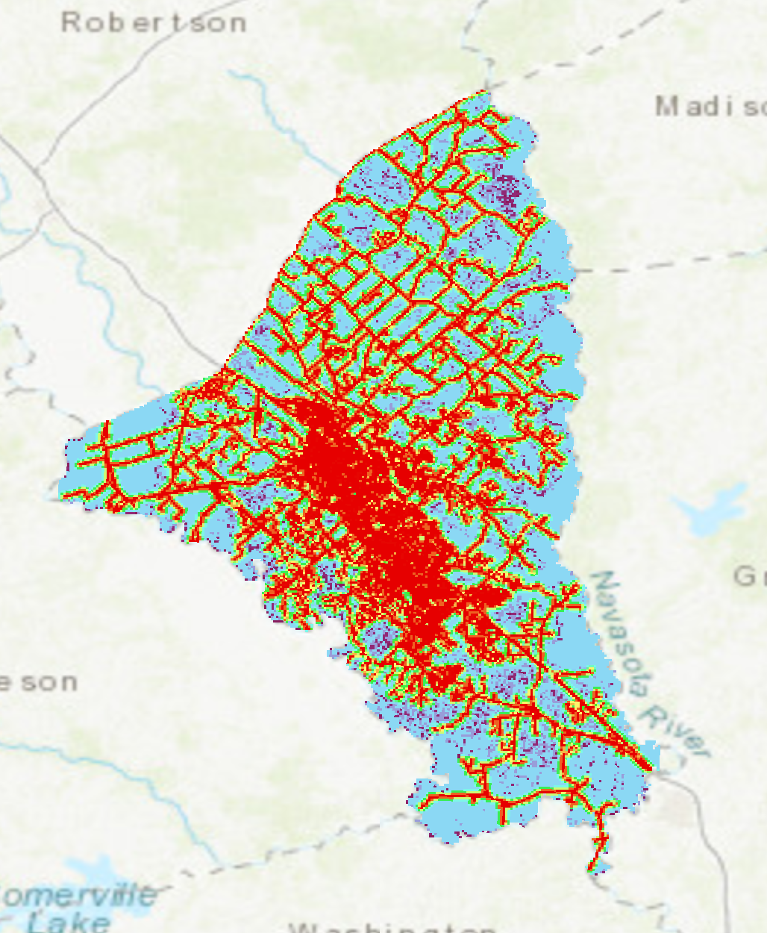

The Left is an image of the suitability site model with topography as the more significantly weighted data. The Right is an image of the suitability site model with roads as the more significantly weighted data. There is a slight difference between the two. The right has more land cover shown as unsuitable in terms of topography. The left has less land cover shown an unsuitable. Changing the weighting changed the amount of land that was deemed unsuitable.

**5. Do you think that the suitability site model accurately represents the best location to build your home in Brazos County? Explain the reasons behind your answer.**

No, there is a lot that goes into selecting a location for building a home. Some examples relate to the soil suitability, the weather, the culture, the neighborhood, the complexity of navigating the neighborhood and the town, and proximity to work. The map above takes a lot into consideration, but there is more data necessary to build a home. I, personally, would want to visit the land to decide the suitability for a home. The map would need more data including personal field data.

**6. If you had to do it all over again (please don’t do this), what would you do differently?**

I would collect my own data from sites I have visited, and I would include much more data in the analysis. Two significant factors are not enough to determine if a plot of land is worth investing in. I would add around five more factors to compare and contrast if the land is suitable for a home.

**2.1**

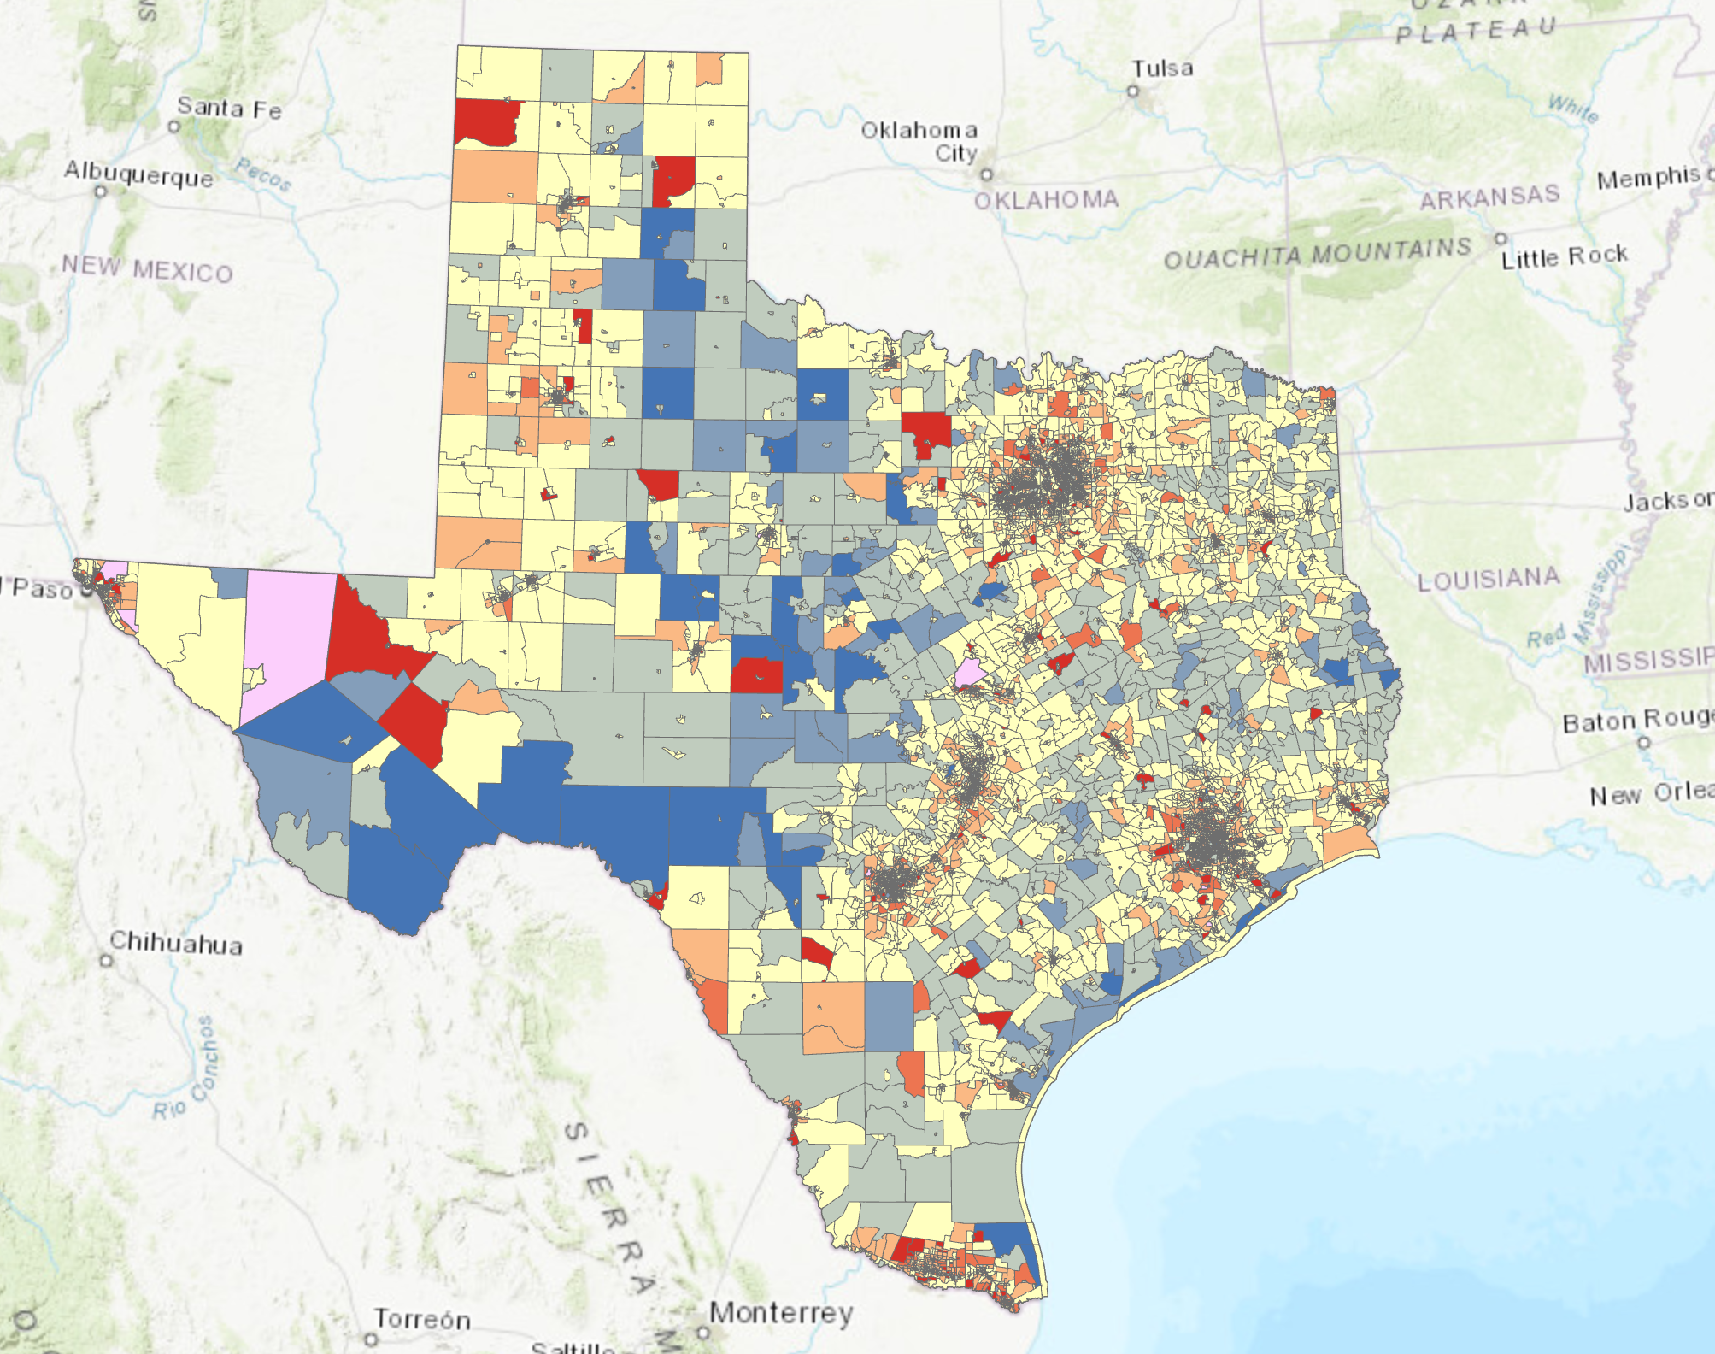

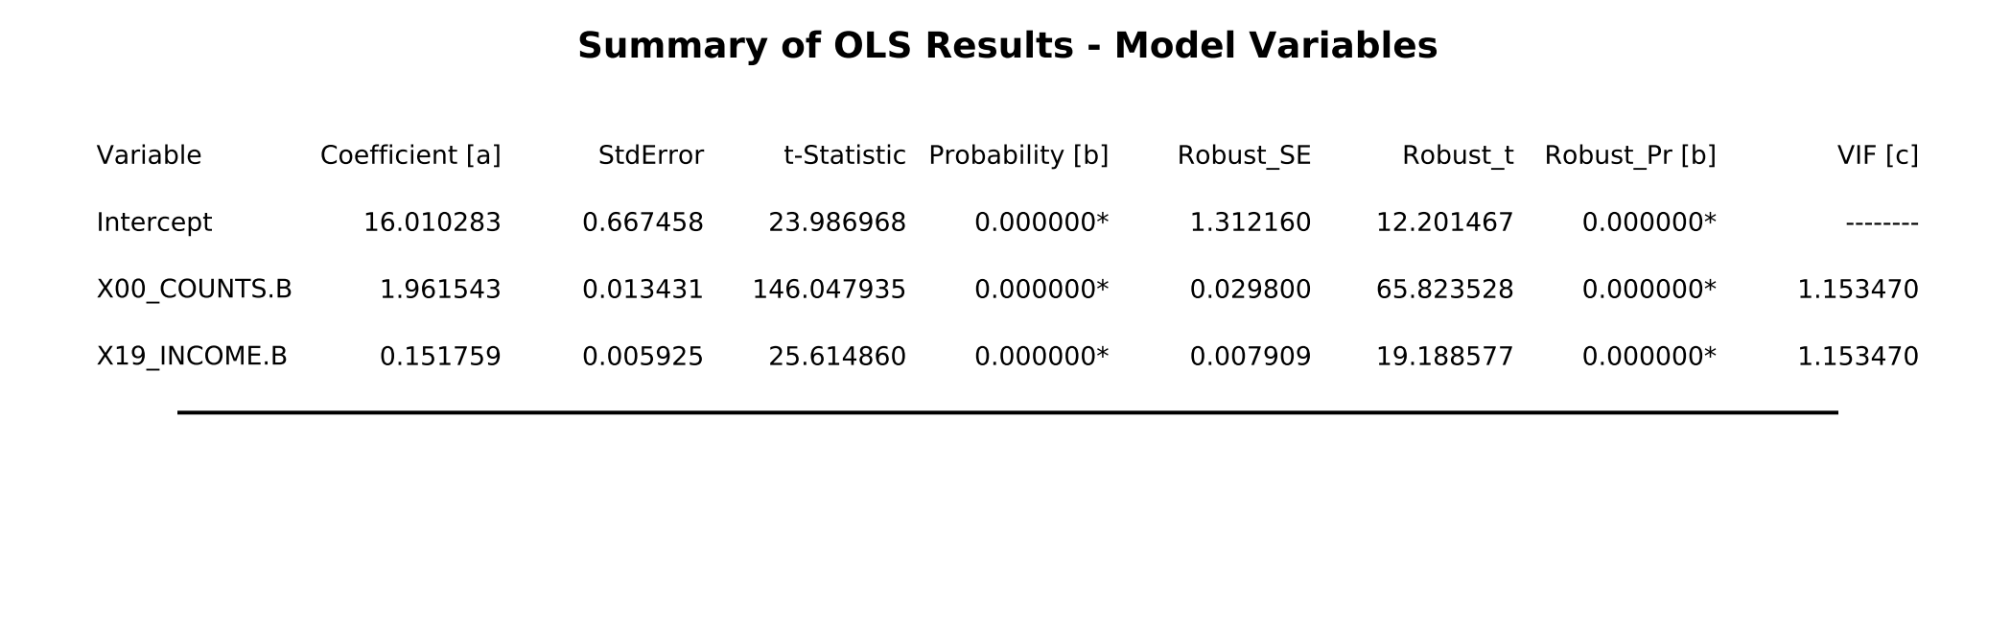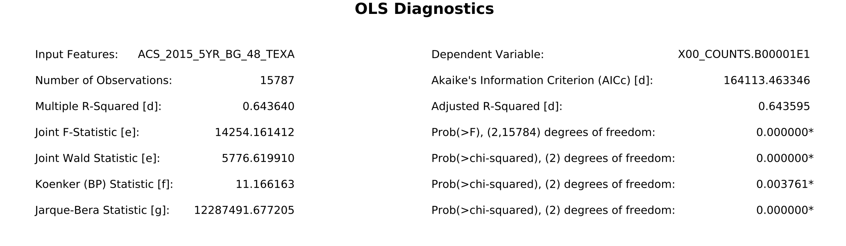

**2.2**

**1. Identify and explain why your initial independent variables should explain the variance in population. For these variables, did you receive good R2 values?**

The independent variables selected were the unweighted sample count of the population and the unweighted sample housing units. These would explain the variance since population as compared with housing comprises the nature of population. I received good R2 values, but I wanted a higher R2 value. I wanted a number closer to 0.6.

**2. What other variables did you test to obtain better R2 values? Describe the reasoning and the statistical results.**

The household income for the last 12 months is the variable I added to the equation to increase my R2 values. This made sense because annual household income is very significant to describing the spatial pattern of the population. Income is the largest limiting factor that determines lifestyle. Income determines where people live, where they are in a city, what cities they can live in, etc. The results that came from this addition included a higher R2 value. The R2 value become 0.643. This was my target R2 value.

**3. Display your map for the highest R2 regression model. Describe the spatial distribution of population. Does a residual map help you explain your results?**

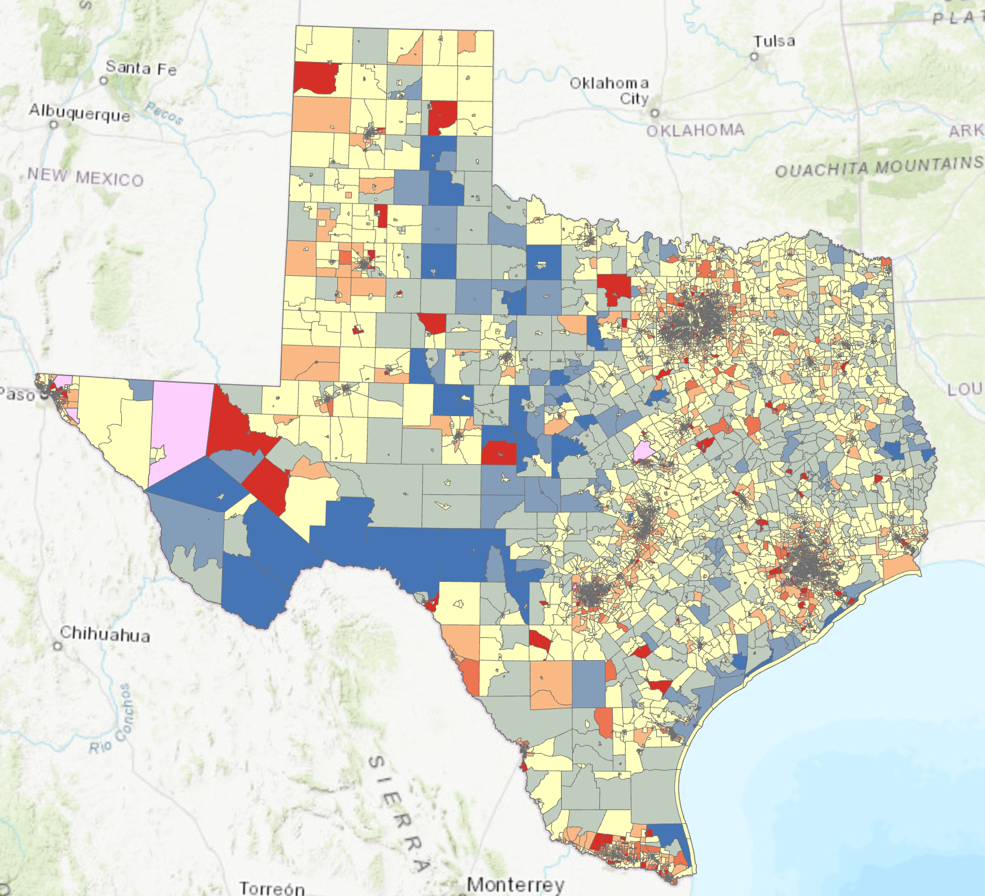

The population density is denser around large cities like Houston and San Antonio. The population density decreases in the smaller cities. The residual map shows a good breakdown of each population in every county. The issue with the residual map is that it is not very user friendly for those whom are not inherently familiar with GIS and the meanings of the terms used.

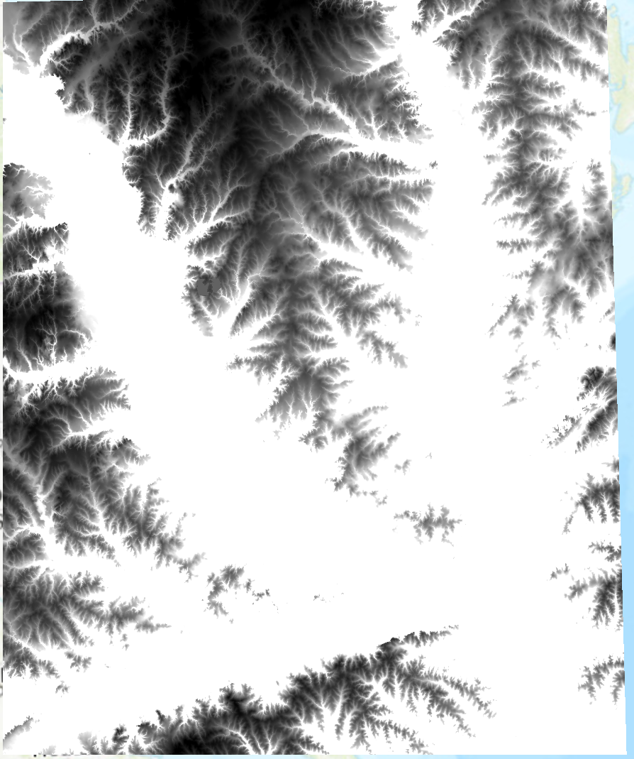

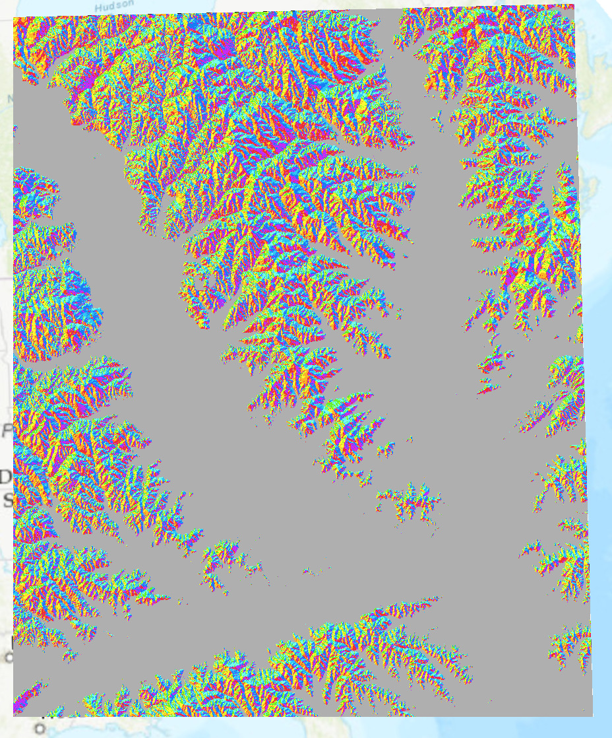

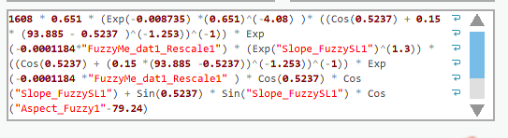

**4.1**

**1. Describe the spatial and temporal patterns associated with cos i.**

Unfortunately, The raster Calculator continued to fail to the point of the equation not being able to be implemented. This was potentially an issue resulting from the way the equation was written or something that was not working from my ArcGIS Pro license.

**2. Describe the spatial and temporal patterns associated with tau↓ . What are they associated with?**

Unfortunately, The raster Calculator continued to fail to the point of the equation not being able to be implemented. This was potentially an issue resulting from the way the equation was written or something that was not working from my ArcGIS Pro license.

**3. Describe the spatial and temporal patterns associated with Eb with your simulation? Do the spatial patterns of irradiance change with time? Are there magnitude differences? What causes this?**

Unfortunately, The raster Calculator continued to fail to the point of the equation not being able to be implemented. This was potentially an issue resulting from the way the equation was written or something that was not working from my ArcGIS Pro license.